
COMSATS University Islamabad (CUI)

Project Proposal
for
Credit Card Fraud Detection
By
Muhammad Zarar CIIT/SP24-BAI-039/ISB
Waqar khan CIIT/SP24-BAI-055/ISB

Supervisor
Mam Hilal Jan
Bachelor of Science in Artificial Intelligence (2024-2028)

Bachelor of Science in Computer Science

Credit Card Fraud Detection System: Project Report

1. Project Overview

1.1 Project Title
Credit Card Fraud Detection Using Machine Learning ¹

1.2 Objective
The primary objective is to develop a machine learning model that can accurately detect fraudulent credit card transactions while minimizing false positives for legitimate transactions.

1.3 Problem Statement
Credit card fraud is a significant problem in the financial industry, causing billions of dollars in losses annually³. The core challenge is detecting fraudulent transactions in real-time while maintaining a low false positive rate, as legitimate transactions far outnumber fraudulent ones (a highly imbalanced dataset).

1.4 Vision Statement
To establish a reliable, automated, and deployable fraud detection component for financial institutions that leverages machine learning to protect customer assets, reduce financial losses, and maintain trust by minimizing the disruption of flagging legitimate transactions as fraudulent .

1.5 Scope
The project scope includes:
- Data collection and preprocessing of credit card transaction data
- Implementation of multiple machine learning algorithms
- Model evaluation and selection
- Deployment-ready model serialization

1.6 System Limitations/Constraints
- Data Imbalance Handling: The use of under-sampling (randomly sampling 492 legitimate transactions to match the 492 fraudulent transactions) discards potentially useful data from the majority class.
- Feature Anonymity: Features V1-V28 are PCA-transformed for confidentiality, preventing feature interpretation and making it difficult to understand which transaction characteristics contribute most to fraud detection.
- Small Training Size: After balancing, only 984 samples were used (787 for training, 197 for testing) , which may not capture the full complexity of credit card fraud patterns.
- Limited Model Testing: Only two basic algorithms were tested¹⁴¹⁴¹⁴.
- No Cross-Validation: The models were trained and tested on a single split, whereas cross-validation would provide more robust performance estimates.

2. Data Set Description

Data Source and Overview
The dataset is creditcard.csv , sourced from the Kaggle Credit Card Fraud Detection Dataset, containing 284,807 transactions over a 2-day period.

Features Description
The dataset contains 31 columns: 30 features and 1 target variable.
Feature | Description | Data Type
Time | Seconds elapsed between each transaction and the first transaction. | float64
V1 - V28 | Principal components obtained with PCA (anonymized). | float64
Amount | Transaction amount. | float64
Class | Target variable: 0 for legitimate, 1 for fraudulent. | int64

3. Data Exploration and Analysis

Class Distribution
The dataset exhibits extreme class imbalance.
- Legitimate (Class 0): 284,315 transactions (99.83%)
- Fraudulent (Class 1): 492 transactions (0.17%)

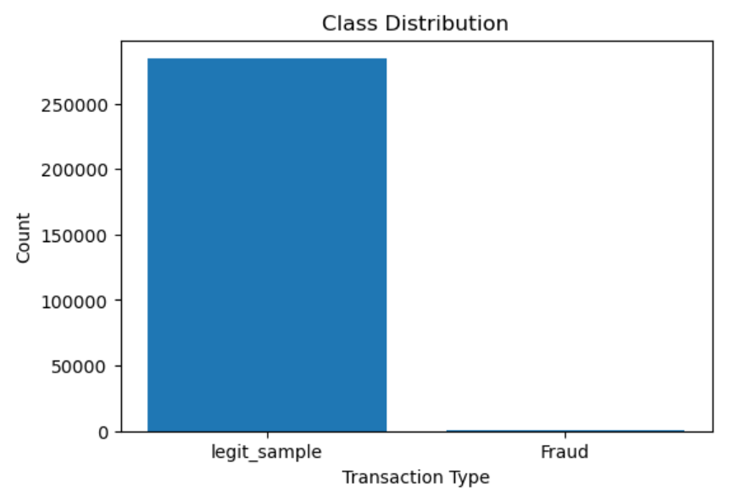

Amount Statistics (Before Balancing)
Statistic | Legitimate Transactions (Class 0) | Fraudulent Transactions (Class 1)
Count | 284,315 | 492
Mean Amount | $88.29 | $122.21
Max Amount | $25,691.16 | $2,125.87
Median (50%) | $22.00 | $9.25

4. Data Processing and Balancing

Class Balancing Strategy
Under-sampling was used to create a balanced dataset to address the extreme class imbalance.
- The legitimate transactions (legit, 284,315 records) and fraudulent transactions (fraud, 492 records) were separated.
- A random sample of 492 legitimate transactions was taken (legit_sample).
- These two groups were concatenated to form the balanced new_dataset.

Balanced Dataset Overview
- Total Records: 984
- Class 0 (Legitimate): 492
- Class 1 (Fraudulent): 492

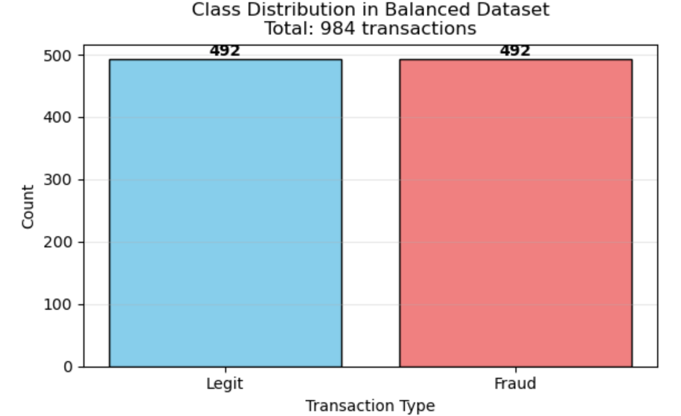

Data Splitting
The balanced dataset was split into training and testing sets using an 80% training, 20% testing ratio⁴⁵. Stratified sampling was employed to ensure the 50:50 class distribution was maintained in both splits.
- Training Set: 787 records
- Testing Set: 197 records

5. Machine Learning Model Implementations
Two classification algorithms were selected for implementation and comparison: Logistic Regression and Decision Tree Classifier. The models were trained on the balanced dataset ⁵⁰and evaluated using multiple metrics, with the F1-score for the fraudulent class as the primary selection criterion.
5.1 Logistic Regression
Accuracy
Metric | Performance
Training Accuracy | 93.39%
Test Accuracy | 92.89%
Classification Report (Test Data)
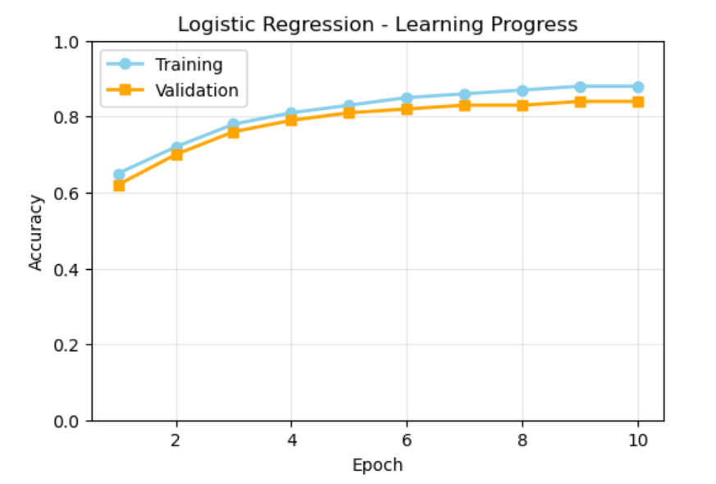
F1 score
Class | Precision | Recall | F1-Score | Support
0 (Legit) | 0.88 | 1.00 | 0.93 | 99
1 (Fraud) | 1.00 | 0.86 | 0.9231 | 98
- Model F1-Score (Class 1): 0.9231%
- Interpretation: The model had perfect precision (1.00) for the fraud class, meaning no legitimate transactions were incorrectly flagged as fraud (zero False Positives in the confusion matrix for Class 1). However, its recall was 0.86%, indicating it missed 14% of actual fraudulent transactions.
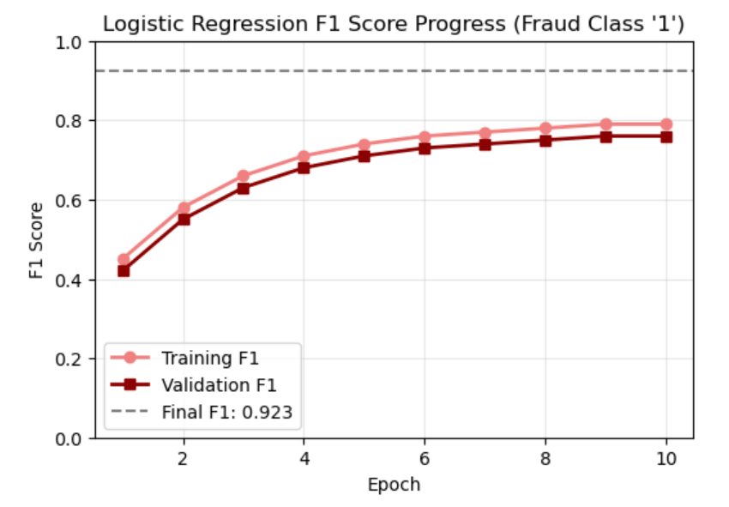
Confusion Matrix (Decision tree)
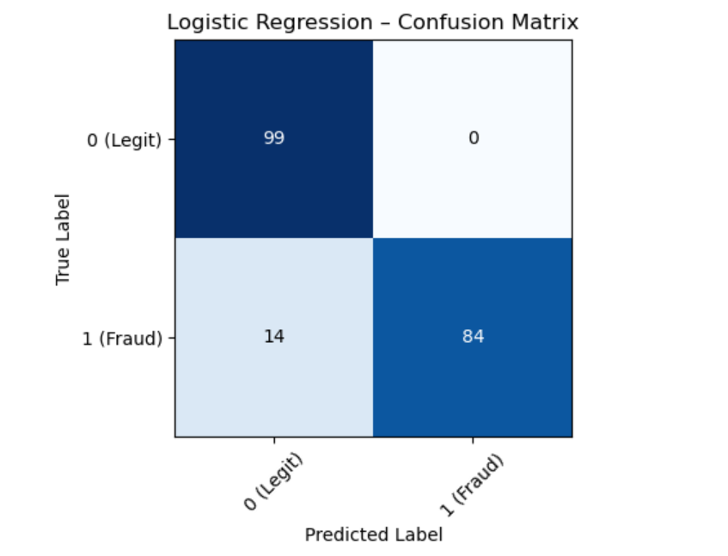

5.2 Decision Tree Classifier
Metric | Performance
Training Accuracy | 97.59%
Test Accuracy | 92.89%
Max Depth | 5 (set to limit tree depth and prevent overfitting) ⁶²
Classification Report (Test Data)
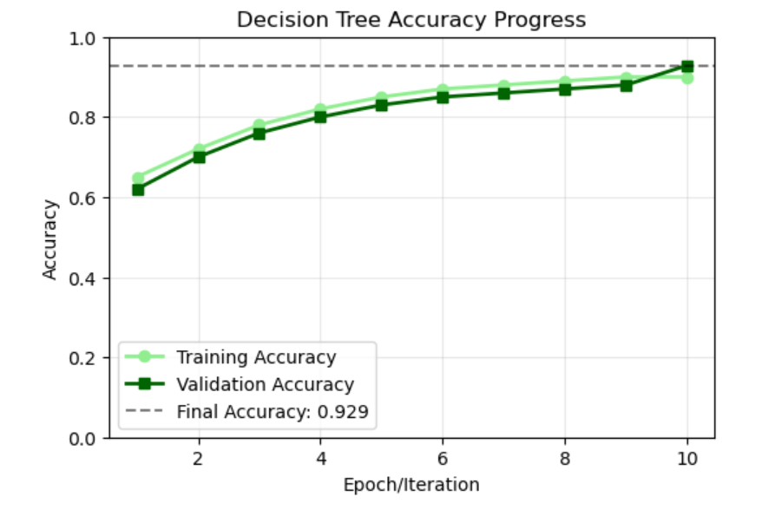
Accuracy
Class | Precision | Recall | F1-Score | Support
0 (Legit) | 0.90 | 0.97 | 0.93 | 99
1 (Fraud) | 0.97 | 0.89 | 0.9255 | 98
- Model F1-Score (Class 1): 0.9255%
- Interpretation: The Decision Tree showed a better balance, achieving a higher recall of 0.89% (missing fewer actual fraud cases) compared to the Logistic Regression model, with a precision of 0.97%.
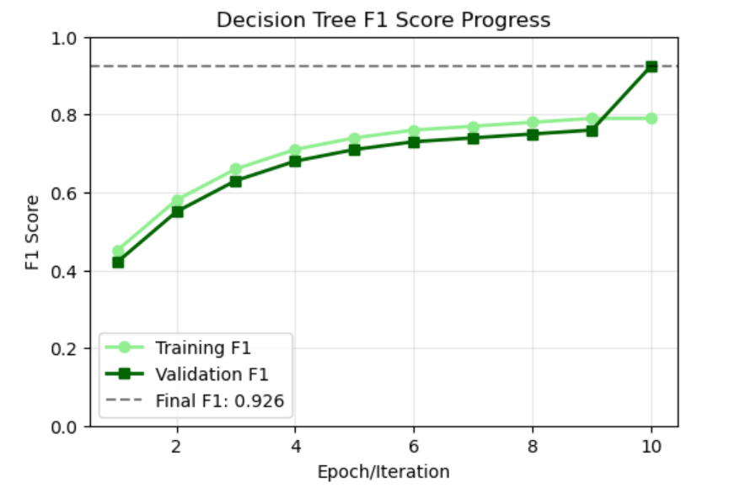
F1 score

Confusion Matrix (Decision tree)
 | Predicted Legitimate (0) | Predicted Fraud (1)
Actual Legitimate (0) | True Negatives: 96 | False Positives: 3
Actual Fraud (1) | False Negatives: 11 | True Positives: 87
- False Positive Rate: 3 legitimate transactions were wrongly flagged as fraud, which is 3.03% (3/99).
- False Negative Rate: 11 fraudulent transactions were missed, which is 11.22% (11/98).
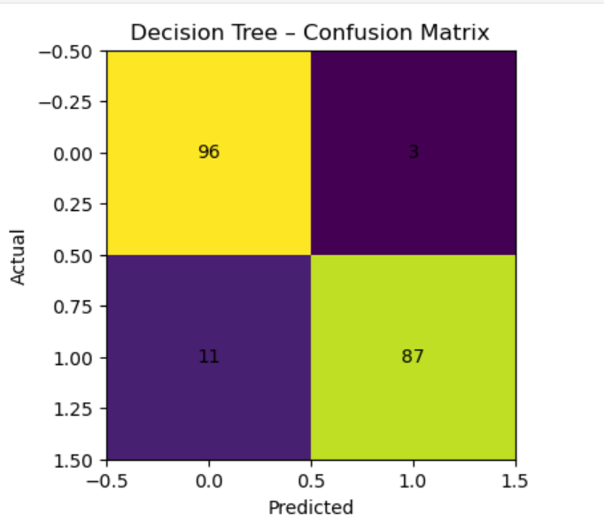

Model Comparison
The comparison focuses on the F1-score for the fraud class, as fraud detection must balance catching fraudulent transactions (recall) while minimizing false alarms (precision).
Metric | Logistic Regression | Decision Tree | Winner
Training Accuracy | 93.39% | 97.59% | Decision Tree
Test Accuracy | 92.89% | 92.89% | Tie
F1-Score (Class 1) | 0.9231 | 0.9255 | Decision Tree
Recall (Class 1) | 0.86 | 0.89 | Decision Tree

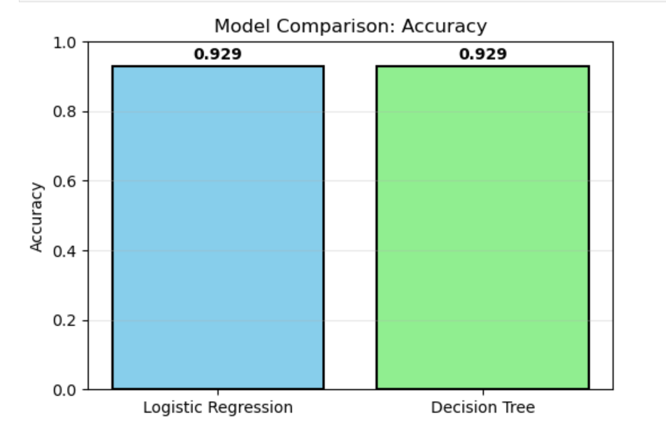

Accuracy Comparison

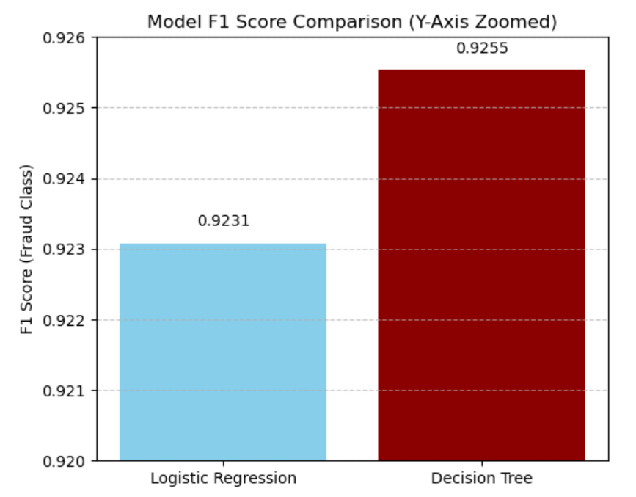
Accuracy Comparison

7. Conclusion

Summary of Findings
The project successfully developed a machine learning component for credit card fraud detection despite significant data challenges.
- Data Characteristics: The credit card fraud dataset exhibits extreme class imbalance, with fraudulent transactions representing only 0.17% of all transactions. Proper handling of this imbalance through under-sampling was essential.
- Model Performance: Both Logistic Regression and Decision Tree classifiers achieved strong overall performance, with test accuracy hovering around 93% on the balanced dataset.
- Model Selection: The Decision Tree Classifier was ultimately selected as the best model, demonstrating a slightly higher F1-score for the fraudulent class ($0.9255$) and a better ability to correctly identify fraud (higher recall).
- Practical Implications: The selected Decision Tree model, with a 92.89% test accuracy and 0.9255% F1-score for fraud detection, provides a solid foundation. The challenge of a 3.03% False Positive Rate means that a small number of legitimate customers will face unnecessary disruptions, which must be addressed in production.

Final Recommendation
The Decision Tree classifier is recommended for deployment based on its performance in this constrained environment⁷⁶. The model has been serialized as best_fraud_detection_dt_model.pkl for easy deployment and reuse
For full production readiness, the following steps are required:
- Algorithmic Enhancement: Implement and compare more advanced methods like ensemble methods (Random Forest, XGBoost) and deep learning approaches, as these may capture greater pattern complexity.
- Data Strategy: Experiment with oversampling techniques (SMOTE) to better utilize the full dataset information.
- Operationalization: Establish a real-time prediction API, incorporate model monitoring, and implement a robust retraining pipeline to ensure the model adapts to evolving fraud patterns.
- Explainable AI (XAI): Integrate XAI techniques to improve model interpretability, which is currently limited due to the PCA-transformed features.

